**Galapagos Southeastern Splendor & Secrets**

# **Itinerary A / Southeastern Islands / 4 Days – 3 nights**

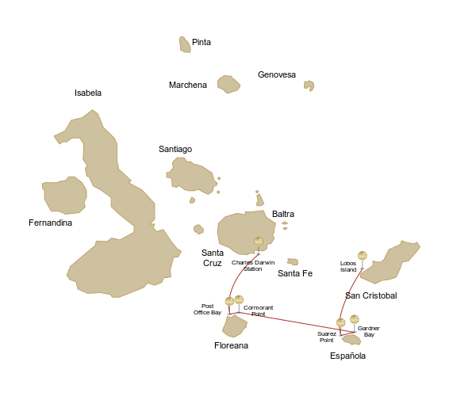

|  |  |  |  | **HIKING** | **SNORKEL** | **PANGA RIDE** | **PADDLE BOARD** | **KAYAK** |
| --- | --- | --- | --- | --- | --- | --- | --- | --- |
| **4 DAYS "A"** | SUNDAY | PM | **San Cristobal:** Lobos Island | • | • | • |  |  |
| MONDAY | AM | **Española:** Suarez Point | • |  |  |  |  |
| PM | **Española:** Gardner Bay | • | • |  | • | • |
| TUESDAY | AM | **Floreana:** Cormorant Point | • | • | • | • | • |
| PM | **Floreana:** Post Office Bay | • | • |  |  |  |
| WEDNESDAY | AM | **Santa Cruz:** Charles Darwin Station | • |  |  |  |  |

# Day 1 – Sunday

AM: ARRIVAL AT SAN CRISTOBAL AIRPORT

Departure to the Galapagos Islands, arrival at San Cristobal airport, where our naturalist guide of the National Park will be waiting for you. 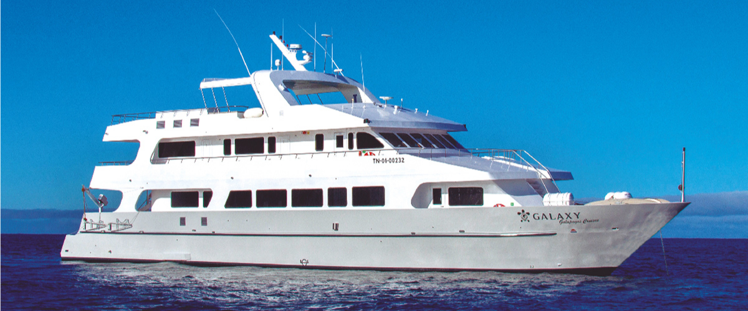

PM:  San Cristobal: Lobos Island

Lobos island is a small islet separated from San Cristobal by a narrow channel, forming a sheltered bay where sea lion pups play in tidal pools. Despite its small size, the island is surprisingly packed with wildlife, especially with “lobos marinos”, the Spanish name for sea lions. Groups of sea lions will welcome you at the landing spot, but as you walk a few steps inland, male frigatebirds displaying their inflated red balloons will be perched on the bushes and trees. A small colony of blue footed boobies, which often nest right on the trail, will give you the opportunity to observe their famous courtship dance.

***Highlights:*** *Galapagos sea lions, marine Iguanas, magnificent & great frigatebirds, blue-footed Boobies, San Cristobal Lava Lizards.*

| **Trail** | 0,6 km / 0,4 mi |
| --- | --- |
| **Meals** | L/D |
| **Activities** | Dry landing and hiking |

# Day 2 – Monday

## AM: Española: Suarez Point

Embrace the morning at Suarez Point. This rocky trail presents a natural gallery of the Galapagos islands, brimming with an awe-inspiring array of fauna. Upon landing, you'll be greeted by sea lions and marine iguanas, your first hosts in this nature carnival. As you venture further, you'll encounter a mosaic of seabird colonies - from the striking Nazca and blue-footed boobies to the elegant gulls and tropicbirds. The pinnacle of this journey brings you face-to-face with the waved albatross, the island's largest bird (present from April to January). This majestic creature, exclusive to Española, will captivate you with its powerful flight and intricate courtship display.

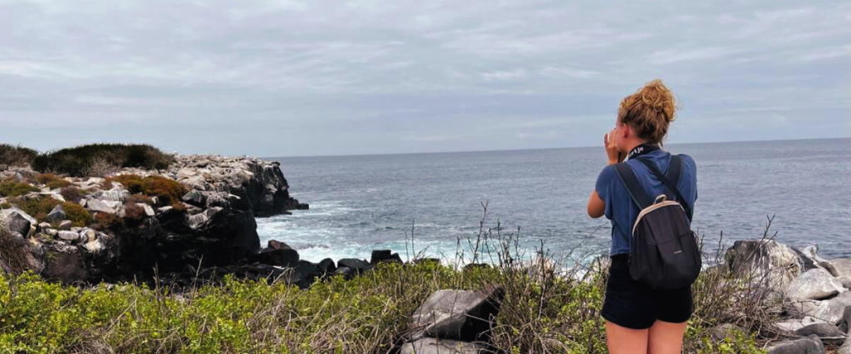

**Highlights:** *Sea lions, Waved Albatross, Galapagos hawks, Española mockingbirds, Darwin finches, marine iguanas, Nazca & Blue-footed Boobies, Red-billed Tropicbirds, Swallow-tailed gulls, herons, lava lizards, herons.*

| **Trail** | 1.7 km / 1.1 mi |
| --- | --- |
| **Level** | 3 |
| **Activities** | Dry landing and hiking |

## PM: Española: Gardner Bay

Transition into the afternoon with a thrilling adventure to Gardner Bay, a pristine piece of paradise in the Galapagos archipelago. Sugar-white coral sands merge with crystal-clear turquoise waters, creating a tropical oasis. Watch as the beach becomes a theater, starring sun-basking sea lions in a playful performance. This idyllic setting invites you to stroll along the coast, immersing yourself in an enlightening experience as you delve into the biology of the endemic fauna - from the melodious Española mockingbird and the unique marine iguanas to the regal Galapagos hawks.

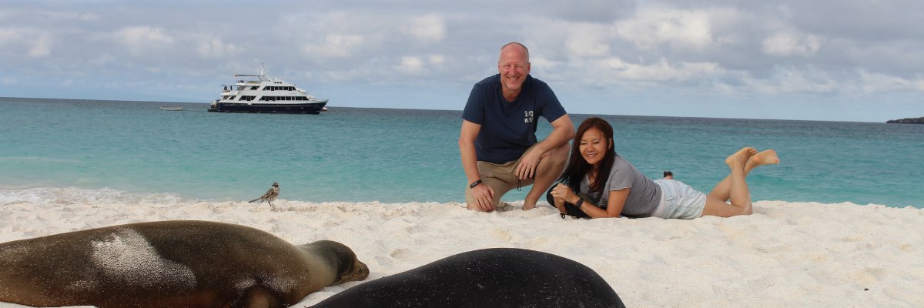

**Snorkeling Experience:** Submerge beneath the azure waves to witness a spectacular performance choreographed by marine life. Swim alongside playful sea lions, graceful reef sharks, and gliding rays. Discover an array of fish, including vivid Angelfish, charismatic Parrotfish, dynamic Damselfish, and the ever-busy Surgeonfish coloring the underwater landscape.

**Highlights:** *Coral sand beach, sea lions, Galapagos hawks, Española mockingbirds, Darwin finches, marine iguanas.*

| **Meals** | B/L/D |
| --- | --- |
| **Trail** | 0,8 km / 0,5 mi |
| **Level** | 1 |
| **Activities** | Wet landing and hiking |

# Day 3 – Tuesday

## AM:  Floreana: Cormorant Point

Shift your expedition northwards to Cormorant Point, renowned for its expansive coastal lagoon teeming with American flamingos, white-cheeked pintails, black-necked stilts, and other shorebirds. This natural haven also features a pristine white sand beach, a crucial nesting ground for green sea turtles, and a newly established breeding ground for blue-footed boobies near the trail. Amidst this vibrant wildlife, also take the opportunity to admire the island's unique flora.

**Highlights:** American flamingo, blue-footed booby, frigatebirds, tropicbirds, Galapagos shearwaters, sea lions, sea turtle nesting site, finches, shorebirds, coral-sand beach.

| **Trail** | 1,6 km / 1 mi |
| --- | --- |
| **Level** | 1 |
| **Activities** | Wet landing and hiking |

## PM: Floreana: Post Office Bay

This locale is imbued with tales from the late 1920s and '30s involving German settlers, a baroness, unsolved mysteries, and captivating intrigue. The bay was a historic anchoring point for whalers, who journeyed to the highlands for freshwater and tortoises. A mail system over two centuries old was established as a hub for visiting vessels centered around a barrel near the beach. This system endures today, offering a unique opportunity to send postcards from this remote part of the world. Apart from its rich history, Post Office Bay presents natural attractions such as a scenic beach, a lava tunnel, and sea tours that can unveil sea lions, green sea turtles, shorebirds, small sharks, and, if luck permits, Galapagos penguins.

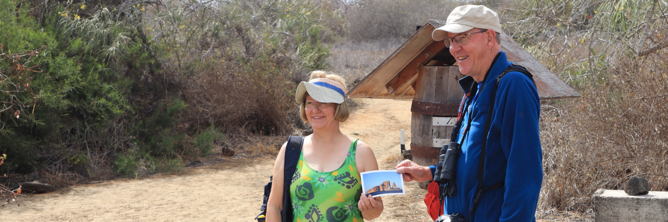

**Snorkeling Experience:** Delve beneath the waves right from the beach, opening up a mesmerizing world of sea turtles, rays, and a diverse plethora of fish. Keep your fingers crossed for a special appearance by the elusive Galapagos penguin.

**Highlights:** Sea Lions, sea turtles, finches, shorebirds, marine iguanas, and penguins.

| **Meals** | B / L / D |
| --- | --- |
| **Trail** | 0,7 km / 0,4 mi |
| **Level** | 1 |
| **Activities** | Wet landing and hiking |

# Day 4 – Wednesday

## AM: Santa Cruz: Charles Darwin Station

Kickstart your day with a profound encounter at the Charles Darwin Station, a dedicated non-profit working hand-in-hand with the Galapagos National Park to safeguard the archipelago's unique biodiversity. This visit provides insights into the collaborative efforts of these institutions to shield native species and combat the invasive ones threatening the delicate balance of the Galapagos ecosystem. One of their emblematic endeavors includes the captive breeding giant tortoises, an integral part of the conservation strategy. Amidst the educational venture, enjoy the setting of an outdoor native dry forest adorned with towering cacti and a rich array of fascinating endemic flora. This is an ideal spot to discover various endemic Darwin finches, as well as vivacious flycatchers and melodious mockingbirds.

As the day winds down, prepare for your return to the Ecuador mainland. Reflect on the extraordinary experiences and memories created as you journey back. The return trip is a time to relax and ponder the unique ecosystems and incredible wildlife you've encountered, leaving the enchanted islands behind but taking a piece of their magic.

This concludes your remarkable journey through the Galapagos, filled with awe-inspiring encounters with nature's wonders, leaving you with a deeper appreciation for the delicate balance of our planet's ecosystems.

**Highlights:** Galapagos giant tortoise & land iguanas breeding program, Darwin finches, Galapagos mockingbirds, Galapagos flycatchers, yellow warblers.

| **Meals** | B |
| --- | --- |
| **Level** | 1 |
| **Activities** | Dry landing and hiking |

# Glossary

| **Meals** | **Breakfast** | B |
| --- | --- | --- |
| **Lunch** | L |
| **Dinner** | D |
| **Hiking Effort** | **Level 1** | Easy |
| **Level 2** | Moderate |
| **Level 3** | Hard |