Galapagos Southeastern Splendor & Secrets

Itinerary A / Please indicate 5 Days – 4 nights

 |  |  |  | HIKING | SNORKEL | PANGA RIDE | PADDLE BOARD | KAYAK
5 DAYS "A" | SATURDAY | PM | San Cristobal: Kicker Rock |  |  | •
 | SUNDAY | AM | San Cristobal: Cerro Brujo (Witch Hill) | • | • | •
 |  | PM | San Cristobal: Punta Pitt | •
 | MONDAY | AM | Española: Suarez Point | • | •
 |  | PM | Española: Gardner Bay | • | • | •
 | TUESDAY | AM | Floreana: Cormorant Point | • | • | • | • | •
 |  | PM | Floreana: Post Office Bay | •
 | WEDNESDAY | AM | Santa Cruz: Charles Darwin Station | •

Day 1 - Saturday

AM: EMBARKATION TO THE GALAPAGOS ISLANDS - SAN CRISTOBAL AIRPORT
Unfurl the sails of adventure and embark on an unforgettable journey to the Galapagos Islands. You'll arrive at San Cristobal Airport, where a seasoned naturalist guide, the custodian of this ecological gem, will greet you. Feel the flutter of anticipation as your exploration of this astonishing world heritage site commences.
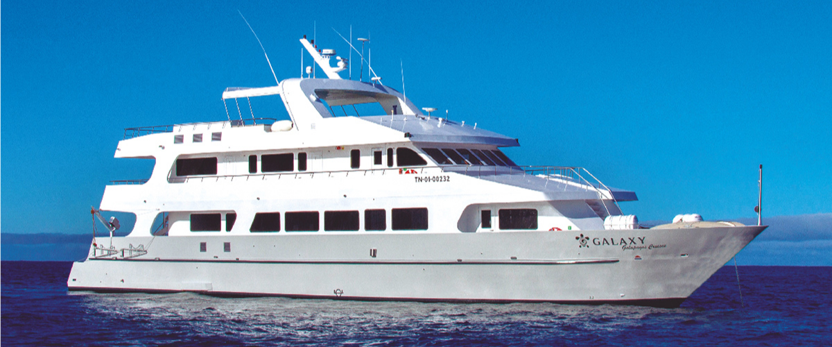
PM: KICKER ROCK
In the afternoon, embark on an unforgettable panga (dinghy) ride around Kicker Rock, also known as León Dormido, off the coast of San Cristobal Island. This impressive rock formation, rising dramatically 500 feet above the ocean, is one of the most iconic landmarks in the Galapagos. The natural erosion of this ancient volcanic tuff cone has created a channel between two towering rock walls, providing a haven for various marine life.
This peaceful and scenic panga ride around Kicker Rock provides a relaxing yet awe-inspiring conclusion to your day, allowing you to appreciate the natural wonders and rich biodiversity of the Galapagos from the sea.
Panga Ride Experience: Navigate the waters around Kicker Rock, marveling at the sheer size and beauty of the formation. The ride offers a unique perspective of the rock, with opportunities to observe seabirds such as frigate birds, boobies, and occasionally, pelicans nesting or resting on its cliffs. Keep an eye out for marine life in the surrounding waters, including sea turtles, rays, and even sharks that frequent the area.
Highlights: Kicker Rock formation, seabirds (frigate birds, boobies, pelicans), marine life sightings.
Meals | L, D
Activities | Panga ride around the rock formation

Day 2 – Sunday

AM: CERRO BRUJO – SAN CRISTOBAL ISLAND
Start your day at Cerro Brujo, a breathtaking white sand beach on San Cristobal Island's northern coast. This beach is one of the first sites visited by Charles Darwin. It's an exquisite spot for walking and enjoying the scenery, with its powdery white sand and turquoise waters. The area is home to a large sea lion colony, and the nearby lagoon often hosts several bird species, including pelicans and blue-footed boobies. The clear waters also make it an ideal spot for snorkeling, where you can encounter rich marine life.
Beach and Snorkeling Experience: Stroll along the white sands of Cerro Brujo, enjoy close encounters with sea lions, and explore the vibrant underwater world.
Highlights: White sand beach, sea lions, pelicans, blue-footed boobies, snorkeling opportunities.
Trail | 0.5 km / 0.3 mi
Level | 1
Activities | Wet landing, beach walking, snorkeling

PM: PUNTA PITT – SAN CRISTOBAL ISLAND
In the afternoon, head to Punta Pitt, located on the eastern end of San Cristobal Island. This unique site is the only place in the Galapagos where you can see all three species of boobies and two species of frigate birds. The trail here offers a challenging hike up a steep path but rewards with stunning views of the coastline. The beach area is also a great spot for snorkeling and swimming, offering a chance to see various marine life.
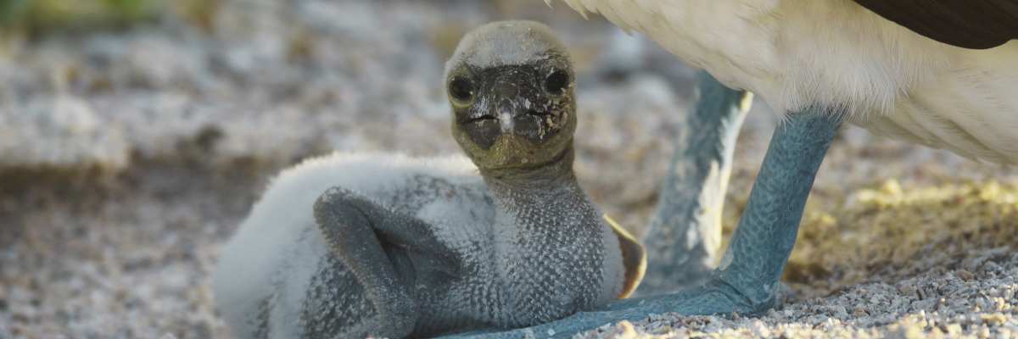
Hiking and Wildlife Observation: Explore the rugged terrain of Punta Pitt and witness the diverse birdlife, including all three booby species and frigate birds.
Highlights: Three booby species (Blue-footed, Red-footed, Nazca), two frigate bird species, stunning views, and snorkeling opportunities.
This day provides a rich experience of San Cristobal Island's diverse landscapes and wildlife, offering both relaxation on a beautiful beach and an adventurous hike with unique wildlife encounters.
Meals | B / L / D
Trail | 1.5 km / 0.9 mi
Level | 3
Activities | Dry landing, hiking, snorkeling

Day 3 – Monday

AM: A WALK-THROUGH NATURE'S GALLERY - SUAREZ POINT
Transition into the afternoon with a thrilling adventure to Suarez Point. This rocky trail presents a natural gallery of the Galapagos islands, brimming with an awe-inspiring array of fauna. Upon landing, you'll be greeted by sea lions and marine iguanas, your first hosts in this nature carnival. As you venture further, you'll encounter a mosaic of seabird colonies - from the striking Nazca and blue-footed boobies to the elegant gulls and tropicbirds. The pinnacle of this journey brings you face-to-face with the waved albatross, the island's largest bird (present from April to January). This majestic creature, exclusive to Española, will captivate you with its powerful flight and intricate courtship display.
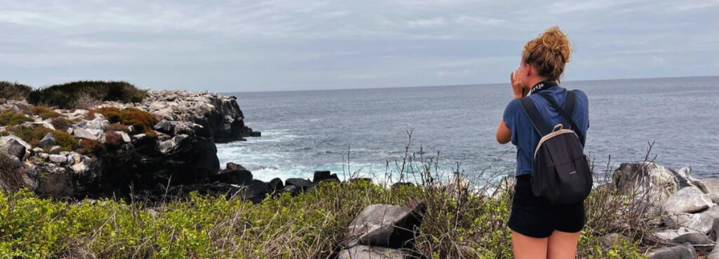
Highlights: Sea lions, Waved Albatross, Galapagos hawks, Española mockingbirds, Darwin finches, marine iguanas, Nazca & Blue-footed Boobies, Red-billed Tropicbirds, Swallow-tailed gulls, herons, lava lizards, herons.
Trail | 1,7 km / 1,1 mi
Level | 3
Activities | Dry landing and hiking

PM: A TROPICAL PARADISE - GARDNER BAY
Embrace the morning at Gardner Bay, a pristine piece of paradise in the Galapagos archipelago. Sugar-white coral sands merge with crystal-clear turquoise waters, creating a tropical oasis. Watch as the beach becomes a theatre, starring sun-basking sea lions in a playful performance. This idyllic setting invites you to stroll along the coast, immersing yourself in an enlightening experience as you delve into the biology of the endemic fauna - from the melodious Española mockingbird and the unique marine iguanas to the regal Galapagos hawks.
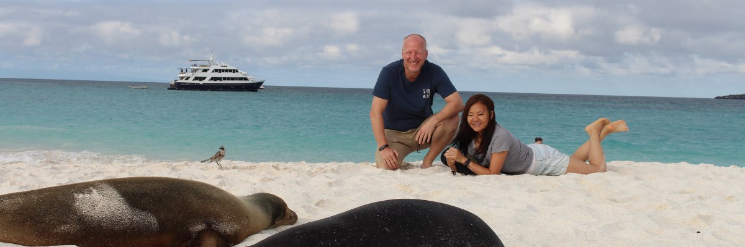
Snorkeling Experience: Submerge beneath the azure waves to witness a spectacular performance choreographed by marine life. Swim alongside playful sea lions, graceful reef sharks, and gliding rays. Discover an array of fish, including vivid Angelfish, charismatic Parrotfish, dynamic Damselfish, and the ever-busy Surgeonfish coloring the underwater landscape.
Highlights: Coral sand beach, sea lions, Galapagos hawks, Española mockingbirds, Darwin finches, marine iguanas.
Meals | B / L / D
Trail | 0,8 km / 0,5 mi
Level | 1
Activities | Wet landing and hiking

Day 4 – Tuesday

AM: THE WONDER OF NATURE - CORMORANT POINT / DEVIL'S CROWN
Shift your expedition northwards to Punta Cormorant, renowned for its expansive coastal lagoon teeming with American flamingos, white-cheeked pintails, black-necked stilts, and other shorebirds. This natural haven also features a pristine white sand beach, a crucial nesting ground for green sea turtles, and a newly established breeding ground for blue-footed boobies near the trail. Amidst this vibrant wildlife, also take the opportunity to admire the island's unique flora.
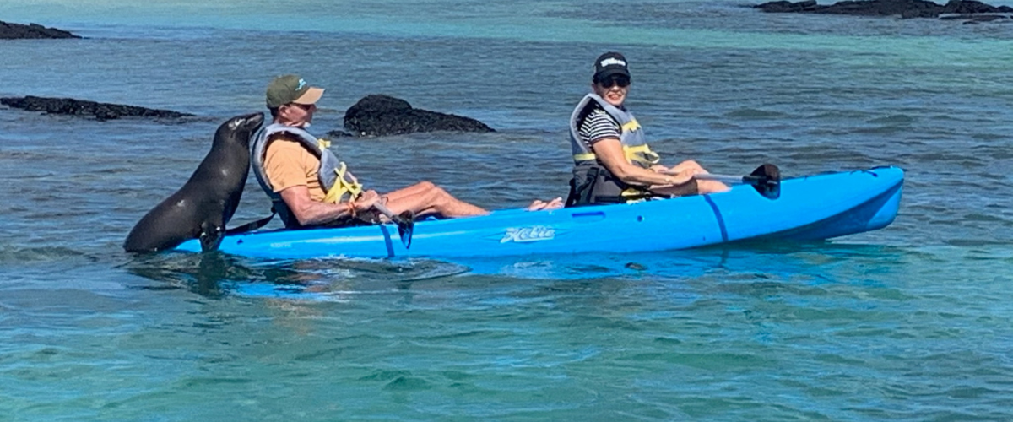
Snorkeling Experience: At Devil's Crown, an eroded little volcano adjacent to Floreana Island, dive into what many consider one of the best snorkeling sites in the entire Galapagos. The Crown's currents funnel plankton, attracting a spectacular congregation of marine life, including snapper, Creole fish, parrot fish, Angelfish, reef sharks, sea turtles, and rays.
Highlights: American flamingo, blue-footed booby, frigatebirds, tropicbirds, Galapagos shearwaters, sea lions, sea turtle nesting site, finches, shorebirds, coral-sand beach.

Trail | 1,6 km / 1 mi
Level | 1
Activities | Wet landing and hiking

PM: MAIL FROM THE PAST - POST OFFICE BAY
Begin your day by stepping into the footprints of the past at Post Office Bay, located on the enigmatic Floreana Island. This locale is imbued with tales from the late 1920s and '30s involving German settlers, a baroness, unsolved mysteries, and captivating intrigue. The bay was a historic anchoring point for whalers, who journeyed to the highlands for freshwater and tortoises. A mail system over two centuries old was established as a hub for visiting vessels centered around a barrel near the beach. This system endures today, offering a unique opportunity to send postcards from this remote part of the world. Apart from its rich history, Post Office Bay presents natural attractions such as a scenic beach, a lava tunnel, and sea tours that can unveil sea lions, green sea turtles, shorebirds, small sharks, and, if luck permits, Galapagos penguins.
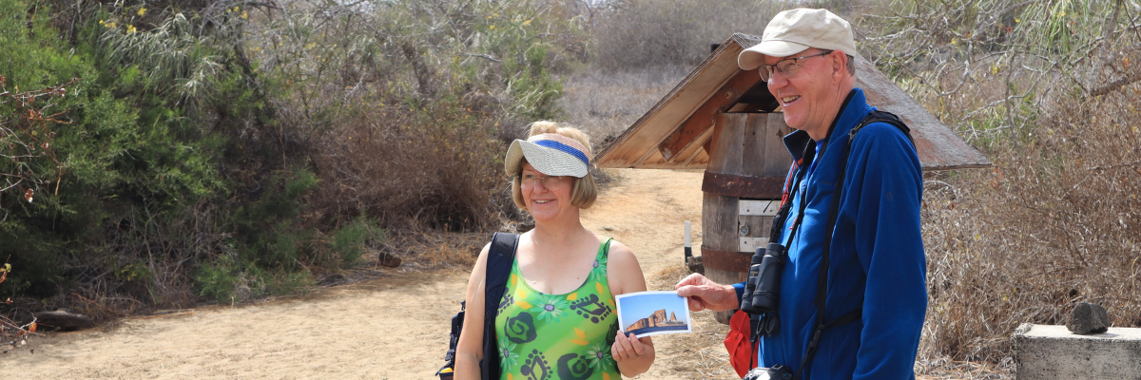
Snorkeling Experience: Delve beneath the waves right from the beach, opening up a mesmerizing world of sea turtles, rays, and a diverse plethora of fish. Keep your fingers crossed for a special appearance by the elusive Galapagos penguin.
Highlights: Sea Lions, sea turtles, finches, shorebirds, marine iguanas, and penguins.
Meals | B / L / D
Trail | 0,7 km / 0,4 mi
Level | 1
Activities | Wet landing and hiking

Day 5 – Wednesday

AM: THE CRADLE OF CONSERVATION - CHARLES DARWIN STATION
Kickstart your day with a profound encounter at the Charles Darwin Station, a dedicated non-profit working hand-in-hand with the Galapagos National Park to safeguard the archipelago's unique biodiversity. This visit provides insights into the collaborative efforts of these institutions to shield native species and combat the invasive ones threatening the delicate balance of the Galapagos ecosystem. One of their emblematic endeavors includes the captive breeding giant tortoises, an integral part of the conservation strategy. Amidst the educational venture, enjoy the setting of an outdoor native dry forest adorned with towering cacti and a rich array of fascinating endemic flora. This is an ideal spot to discover various endemic Darwin finches, as well as vivacious flycatchers and melodious mockingbirds.
As the day winds down, prepare for your return to the Ecuador mainland. Reflect on the extraordinary experiences and memories created as you journey back. The return trip is a time to relax and ponder the unique ecosystems and incredible wildlife you've encountered, leaving the enchanted islands behind but taking a piece of their magic.
This concludes your remarkable journey through the Galapagos, filled with awe-inspiring encounters with nature's wonders, leaving you with a deeper appreciation for the delicate balance of our planet's ecosystems.
Highlights: Galapagos giant tortoise & land iguanas breeding program, Darwin finches, Galapagos mockingbirds, Galapagos flycatchers, yellow warblers.
Meals | B
Level | 1
Activities | Dry landing and hiking

Glossary

Meals | Breakfast | B
 | Lunch | L
 | Dinner | D
Hiking Effort | Level 1 | Easy
 | Level 2 | Moderate
 | Level 3 | Hard

