GALAPAGOS ONBOARD A CRUISE
4 DAYS / 3 NIGHTS YACHT GALAXY

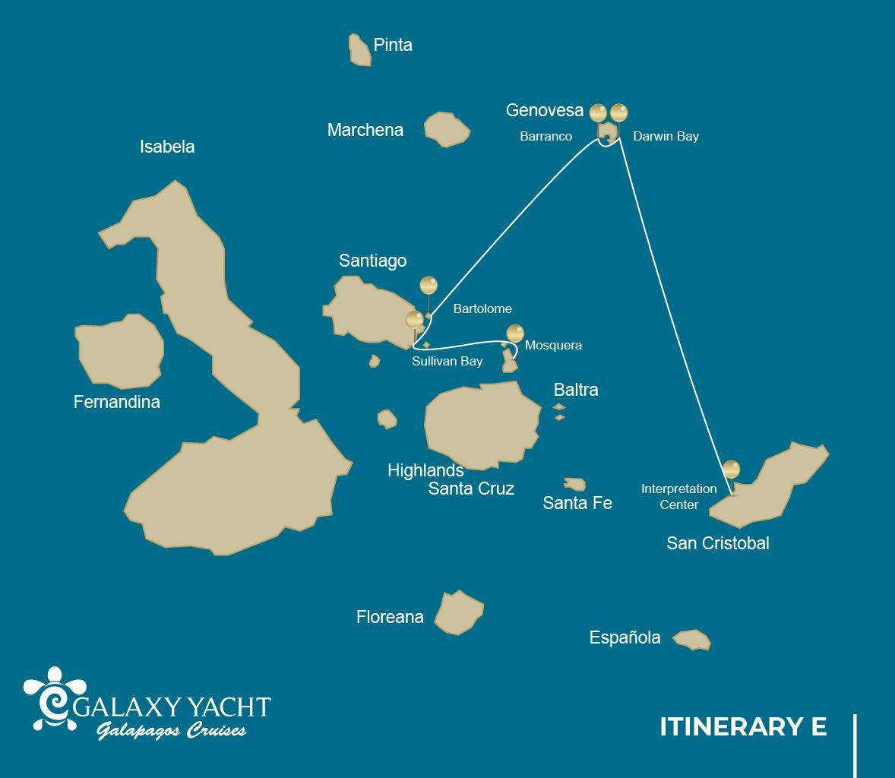

 |  |  |  | HIKING | SNORKEL | PANGA RIDE | PADDLE BOARD | KAYAK
4 DAYS "E" | SATURDAY | PM | Mosquera: Mosquera | •
 | SUNDAY | AM | Santiago: Sullivan Bay | • | •
 |  | PM | Bartolome: Bartolome | • | • | •
 | MONDAY | AM | Genovesa: El Barranco | • | • | • | • | •
 |  | PM | Genovesa: Darwin Bay | • | • | • | • | •
 | TUESDAY | AM | San Cristobal: Interpretation Center | •

DAY 1
AM: BALTRA AIRPORT
Departure to the Galapagos Islands, arrival at Baltra airport, where our naturalist guide of the National Park will be waiting for you.
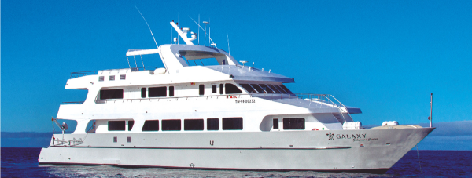
PM: MOSQUERA
Mosquera is mostly a barren sand bar with some rocky areas and scattered salt-resistant plants. You can walk along the beach and enjoy seeing playful sea lion pups surfing the waves and having a great time in the tide pools. Look for endemic lava gulls which are often seen flying over the beach in the search of food.
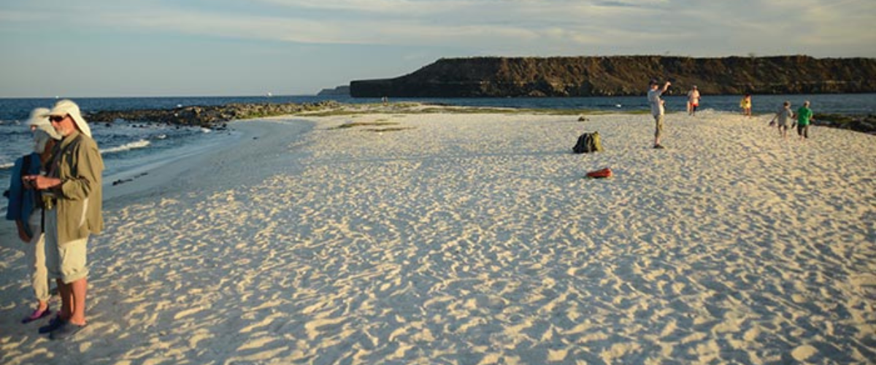
Highlights: Galapagos sea lions, lava gulls, oystercatchers, shorebirds,
Meals | L / D
Trail on the sandy area | 0,6 km / 0,4 mi
Level | 1
Activities | Wet landing and hiking

DAY 2
AM: SULLIVAN BAY
This hike is a journey into understanding the birth of these volcanic islands. You will walk in a very well preserved flow of Pahoehoe lava, which will give you endless opportunities to see the delicate textures of these type of lavas which only appear in a few places throughout the world. At first sight the barren landscape looks completely deprived of life, but look carefully for pioneer plants, lava lizards and small birds. By the shore, you can find penguins, pelicans and oystercatchers.
Snorkel: You will have the option to swim or snorkel from a coral sand beach or from the dinghies. Getting underwater is like traveling to another world: if the land is almost lifeless, the sea is teaming with life, including large schools of fish, Galapagos penguins, reef sharks, turtles and rays.
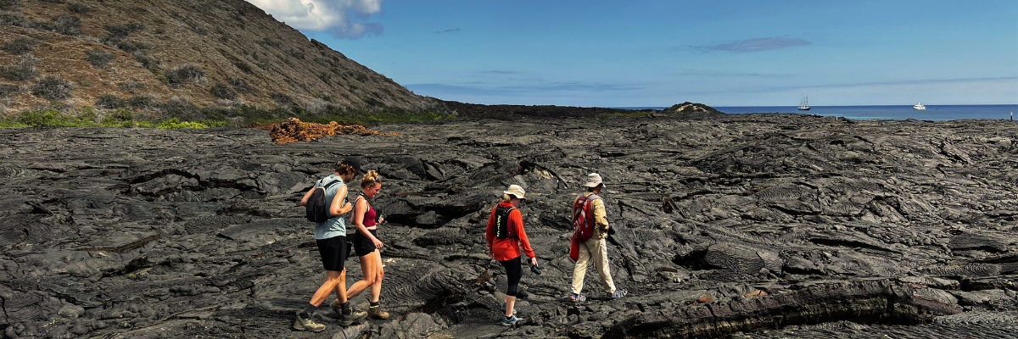
Highlights: Pahoehoe lava, Galapagos penguins, oystercatchers, Galapagos hawks.
Trail | 2,2 km / 1,4 mi
Level | 3
Activities | Dry landing and hiking

PM: BARTOLOME
Bartolome is one of the most iconic places in the Galapagos and one of the few where you can see penguins without going to the remote areas of western Isabela and Fernandina. You will get great views of Pinnacle Rock, located in the northern side of the island, right next to a beautiful peach-color sand beach.
The hike to the top of the island is fantastic and will offer you incredible views of lunar landscapes with scattered volcanic cones. Many islands are visible from this outlook, as well as the bay of Sullivan and the Pinnacle rock.
Snorkel: You will have the option to swim or snorkel from the beach. This area holds a well-deserved reputation of being one of the best snorkeling places in the Galapagos, not only because it’s clear and calm water, but also because of the presence of penguins, which are relatively easy to find while snorkeling, along with an incredible diversity of fish, colorful invertebrates, sea lions, turtles, rays and reef sharks.
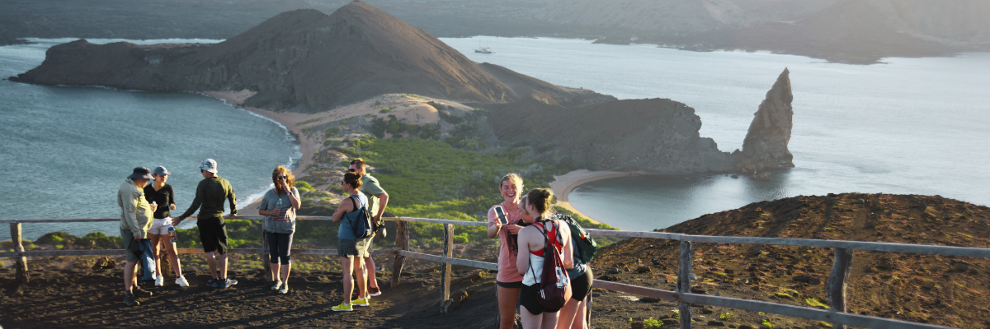
Highlights: Galapagos penguins, volcanic landscapes, Pinnacle rock, blue- footed boobies, herons, sea lions, sharks.
Meals | B / L / D
Trail | 1,5 km / 0,9 mi
Level | 2
Activities | Dry landing and hiking

DAY 3
The itinerary of Genovesa, Darwin Bay, and El Barranco, established on this day, has been changed on September 20, 2023, by the Galapagos National Park Directorate (GNPD) due to a Contingency Plan for the Conservation of Species on this island. In its place, visits will be made to the neighboring islands based on the authorization of the Galapagos National Park.
This itinerary will return to normal when the GNPD considers it optimal for the reception of passengers again on Genovesa Island.
AM: SAN CRISTOBAL ISLAND: CERRO BRUJO
at magic and mystique, rings true: its beaches are so pure they appear untouched by time. It's a treasured spot for those seeking an authentic communion with nature, boasting playful sea lions and diverse seabirds. Visitors can bask in the serene beauty of this coastal gem.

Snorkeling: Cerro Brujo offers a unique snorkeling experience. Swim alongside curious marine life and perhaps enjoy a moment with a sea turtle or manta ray.

Highlights | Diverse tropical fish stunning corals.
Difficulty | Level 3
Type of landing | Wet landing

PM: SAN CRISTOBAL ISLAND: HIGHLANDS
The Highlands of San Cristobal are one of the Galápagos Islands' most verdant and breathtaking landscapes. Its name, evoking elevations and lush terrains, is fitting: the area is a sanctuary of giant tortoises and offers a mosaic of biodiversity. This green haven is a must-visit for those longing for a deeper connection with nature. Here, the essence of the island truly comes alive.

Exploration: In the highlands, trek through mist-covered forests and perhaps witness the graceful movement of a giant tortoise in its natural habitat.

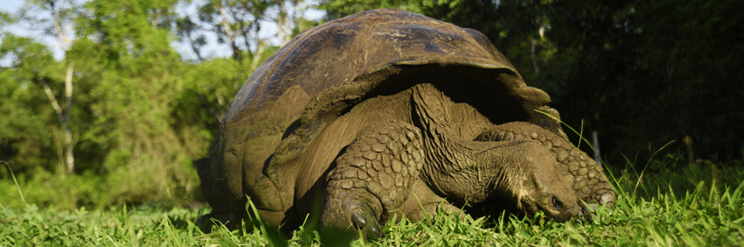
Highlights: Galapagos Giant Tortoises
Meals | B / L / D
Level | 3
Activities | Hiking

DAY 4
AM: INTERPRETATION CENTER
Located in the outskirts of Puerto Baquerizo, this center is dedicated to the history of human presence in the Galapagos. Since the times of the early Spanish explorers to the present times, including illustrious visitors such as Charles Darwin, this permanent exhibition will take you through the dangers and struggles of the first settlers trying to survive the harsh Galapagos environment.
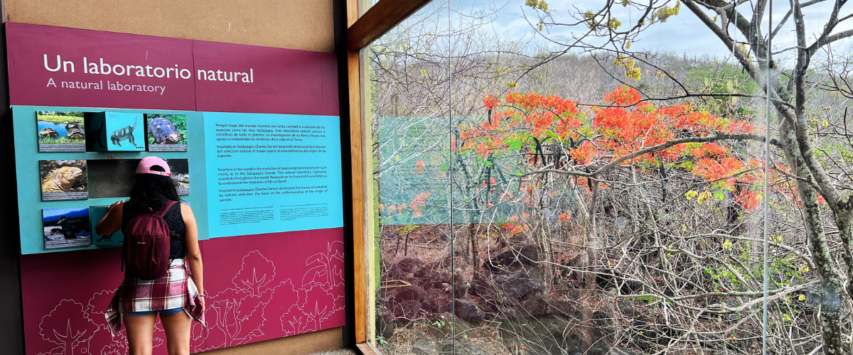
Highlights: Endemic plants, exhibition on human history
Meals | B
Trail | 0,2 km
Level | 1
Activities | Dry landing and hiking

Glossary

Meals | Breakfast | B
 | Lunch | L
 | Dinner | D
Hiking Effort | Level 1 | Easy
 | Level 2 | Moderate
 | Level 3 | Hard

