Galapagos Northeast Discovery and Diversity

Itinerary C / Northeast islands / 5 Days – 4 nights
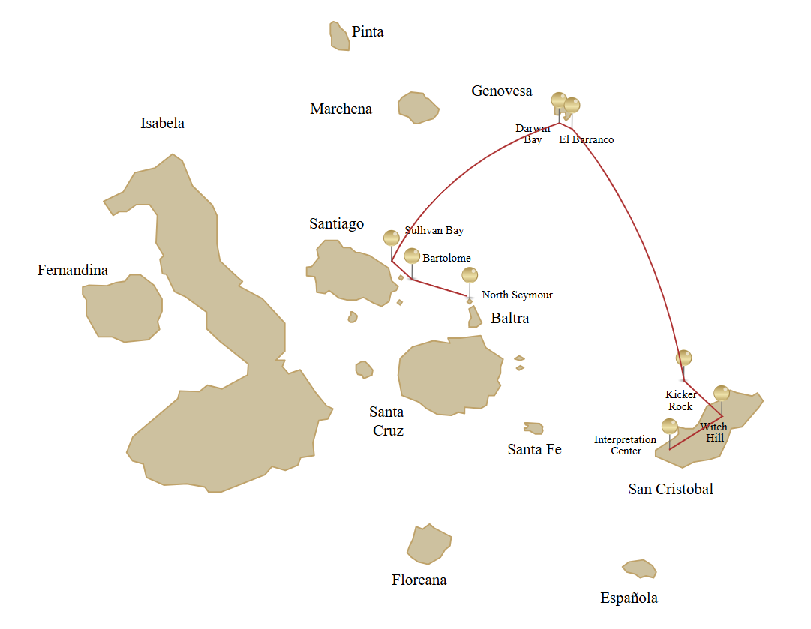

 |  |  |  | HIKING | SNORKEL | PANGA RIDE | PADDLE BOARD | KAYAK
5 DAYS "C" | WEDNESDAY | PM | Seymour: North Seymour | • | • | •
 | THURSDAY | AM | Santiago: Bartolome | • | • | •
 |  | PM | Santiago: Sullivan Bay | • | •
 | FRIDAY | AM | Genovesa: Darwin Bay | • | • | • | • | •
 |  | PM | Genovesa: El Barranco | • | • | • | • | •
 | SATURDAY | AM | San Cristobal: Kicker Rock
 |  | PM | San Cristobal: Witch Hill | • | • | • | • | •
 | SUNDAY | AM | San Cristobal: Interpretation Center | •

Day 1 – Wednesday
AM: BALTRA AIRPORT
Departure to the Galapagos Islands, arrive at Baltra airport, where a National Park-certified naturalist guide will warmly welcome you to this biodiversity-rich paradise. Your exciting journey in the footsteps of Darwin is about to start!
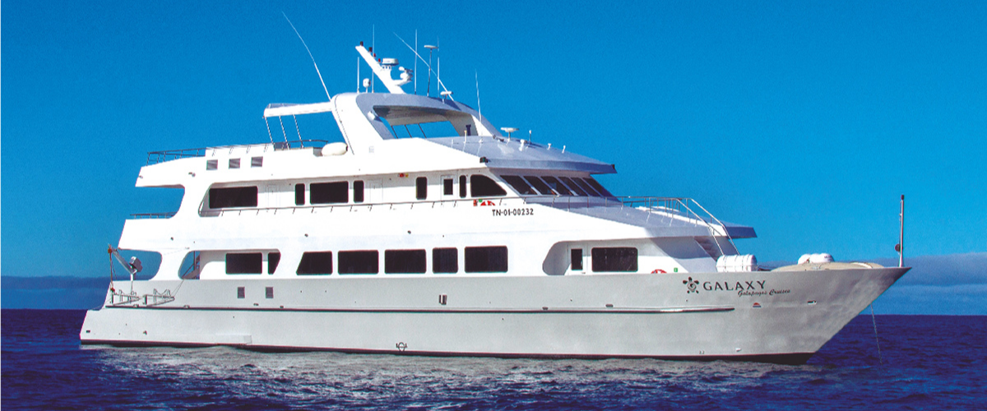
PM: Seymour: North Seymour
Your journey continues with a morning visit to North Seymour Island, a spectacular showcase of the Galapagos Islands' diverse wildlife. This relatively flat island is home to a thriving population of blue-footed boobies and frigate birds. The trail winds its way through a forest of low, bushy vegetation, where you'll have the opportunity to witness the fascinating courtship dance of the blue-footed boobies. The island's coastline also allows one to observe sea lions and marine iguanas basking in the sun. The large frigate bird colonies are a sight, especially when the males inflate their bright red throat pouches to attract mates.
Birdwatching Experience: Encounter the majestic frigate birds and charming blue-footed boobies in their natural habitat. This is an ideal spot for birdwatching and photography.
Highlights: Blue-footed boobies, frigate birds, sea lions, marine iguanas.
Meals | B / L / D
Trail | 2 km
Level | 2
Activities | Dry landing, hiking

Day 2 –Thursday

AM: Santiago: Bartolome
Bartolome Island is one of the most iconic places in the Galapagos, renowned for its accessible penguin population and the beautiful Pinnacle Rock. The beach near the rock is painted with peach-colored sand, adding to the surreal beauty of the landscape. A hike to the island's summit will offer you panoramic views of lunar-like landscapes dotted with volcanic cones, numerous islands, Sullivan Bay, and, of course, the towering Pinnacle Rock.
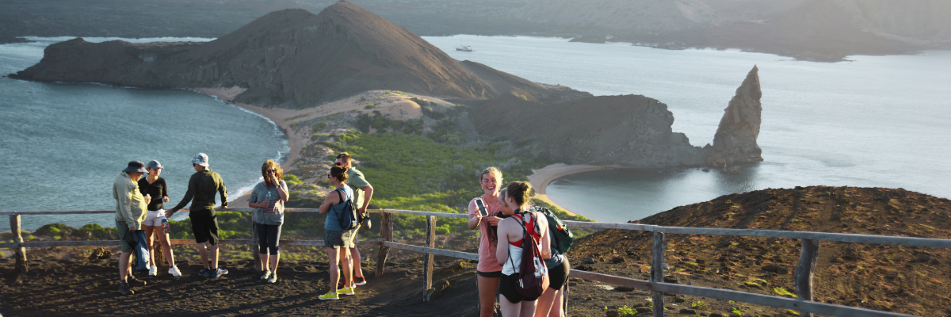
Snorkeling Experience: Following the hike, you have the option to swim or snorkel from the beach. This location boasts a well-deserved reputation as one of the best snorkeling spots in the Galapagos, with its clear, calm water and diverse underwater life. This includes penguins, which are surprisingly easy to spot, along with many colorful fish, invertebrates, playful sea lions, turtles, rays, and reef sharks.
Highlights: Galapagos penguins, volcanic landscapes, Pinnacle rock, blue-footed boobies, herons, sea lions, and sharks.
Trail | 1,5 km / 0,9 mi
Level | 2
Activities | Dry landing and hiking

PM: Santiago: Sullivan Bay
Walking through Sullivan Bay offers an extraordinary journey into the volcanic origins of the Galapagos Islands. Your hike will take you across a perfectly preserved Pahoehoe lava flow, providing endless opportunities to observe the delicate textures of this rare type of lava. While the landscape may appear barren and lifeless at first, a closer look reveals resilient pioneer plants, scurrying lava lizards, and small birds. Along the shore, penguins, pelicans, and oystercatchers add a touch of life to the stark environment.
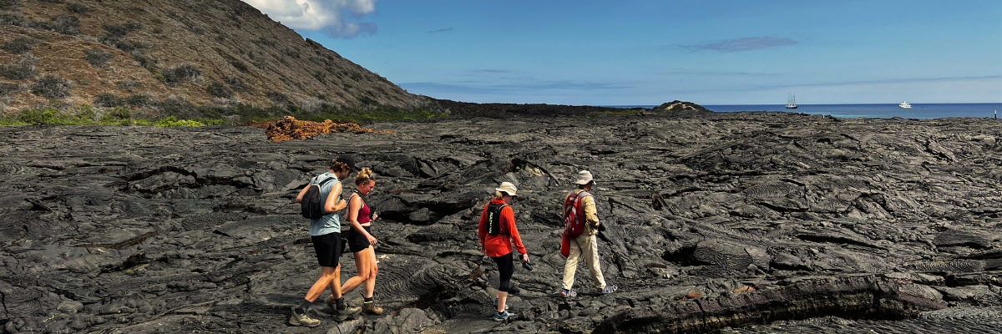

Snorkeling Experience: Following the hike, you can swim or snorkel from a coral sand beach or the dinghies. The underwater world here starkly contrasts the sparse land, teeming with schools of fish, Galapagos penguins, reef sharks, turtles, and rays.
Highlights: Pahoehoe lava, Galapagos penguins, oystercatchers, Galapagos hawks.
Meals | B / L / D
Trail | 2,2 km / 1,4 mi
Level | 3
Activities | Dry landing and hiking

Day 3 – Friday

AM: Genovesa: Darwin Bay
Darwin Bay on Genovesa Island is a birder's dream come true. When you set foot on the beach, you will be amazed by the spectacle of hundreds of boobies, gulls, and frigatebirds soaring above, nesting in the bushes, or roosting on the sandy terrain. This immersive wildlife trail hosts sea lions and marine iguanas by the sea, and inland you'll encounter night herons, lava and swallow-tailed gulls, Darwin finches, Galapagos doves, mockingbirds, and more.
Snorkeling Experience: Darwin Bay offers a variety of snorkeling locations, from deep waters along the bay's cliffs to shallow waters near the beach. Regardless of where you choose, a colorful variety of fish awaits your visit, with a high chance of spotting sharks, rays, and sea lions.
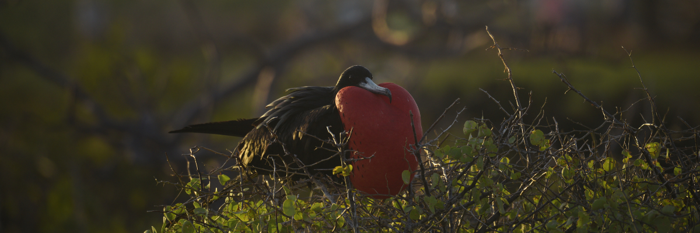

Highlights: Nesting great frigatebirds, red-footed & Nazca boobies, Galapagos sea lions, lava & swallow-tailed gulls, yellow-crown night herons, Genovesa ground finch, Genovesa cactus finch, Galapagos mockingbirds.
Trail | 1,2 km / 0,7 mi
Level | 3
Activities | Wet landing and hiking

PM: Genovesa: El Barranco
Located in the southern part of Darwin Bay on Genovesa Island, El Barranco is blessed with cliffs facing the sea made from very fragile, fractured lava. This creates an ideal nesting environment for storm petrels, attracting a significant population of short-eared owls. The trail is dotted with red-footed and Nazca boobies. At the same time, the base of the cliffs provides restful, shaded areas for Galapagos fur seals and numerous seabirds.
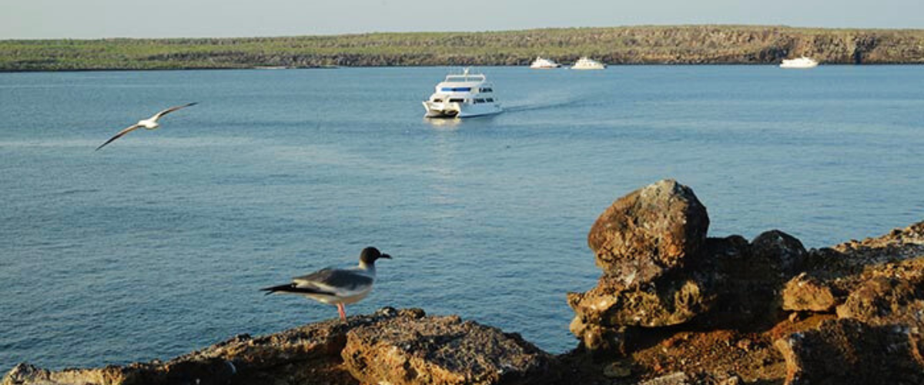
Snorkeling Experience: Snorkeling alongside these cliffs is an exhilarating experience, teeming with diverse fish and providing great chances to see sharks, rays, and playful sea lions.
Highlights: Nesting great frigatebirds, red-footed & Nazca boobies, Galapagos sea lions, Galapagos fur seals, lava & swallow-tailed gulls, yellow-crown night herons, Genovesa ground finch, Genovesa cactus finch, Galapagos mockingbirds.
Trail | 1,2 km / 0,7 mi
Level | 3
Activities | Wet landing and hiking

Day 4 – Saturday

AM: San Cristobal: Kicker Rock
Kicker Rock is a striking formation made of two vertical rocks rising 500 feet from the ocean. The narrow channel between these impressive cliffs serves as a pathway for marine life, creating a stunning backdrop for snorkeling and diving. This is a prime spot to observe a variety of marine species, including sharks, rays, and tropical fish. Kicker Rock is also a significant area for nesting seabirds like frigatebirds and boobies.
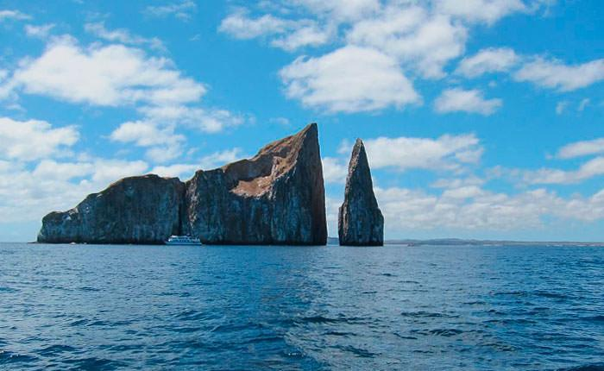
Highlights: Endemic plants, exhibition on human history
Trail | 0,2 km / 650 ft
Level | 1
Activities | Circumnavigation

PM: San Cristobal: Witch Hill
It's an exquisite spot for walking and enjoying the scenery, with its powdery white sand and turquoise waters. The area is home to a large sea lion colony, and the nearby lagoon often hosts several bird species, including pelicans and blue-footed boobies.
Beach and Snorkeling Experience: Stroll along the white sands of Witch Hill, enjoy close encounters with sea lions, and explore the vibrant underwater world.
Highlights: White sand beach, sea lions, pelicans, blue-footed boobies, snorkeling opportunities.
Trail | 0.5 km / 0.3 mi
Level | 1
Activities | Hiking

Day 5 – Sunday

AM: San Cristobal: Interpretation Center
Situated on the outskirts of Puerto Baquerizo, the Interpretation Center serves as a rich repository of the history of human presence in the Galapagos Islands. Its exhibitions chronicle the stories of early Spanish explorers up to the present day, highlighting prominent visitors such as Charles Darwin. The displays at this center illustrate the challenges and perils faced by the first settlers as they endeavored to survive in the rugged Galapagos environment.
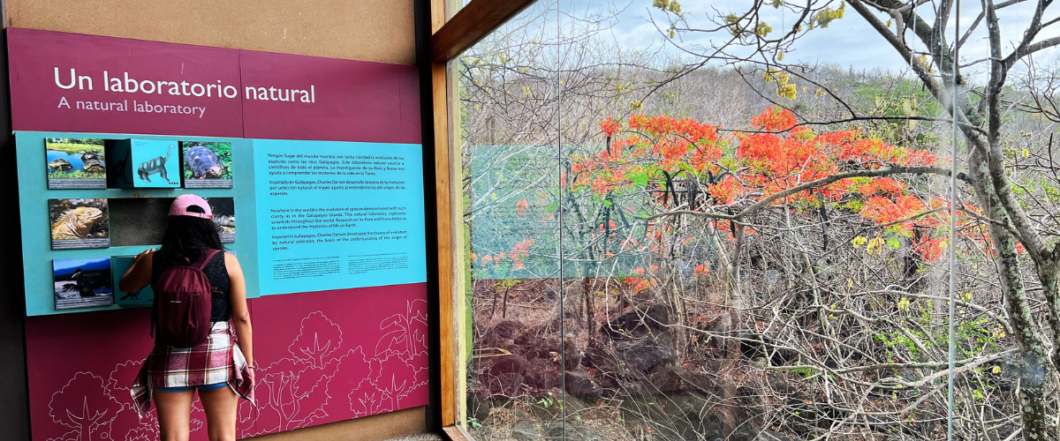
Meals | B
Level | 1
Activities | Dry landing and hiking

Glossary

Meals | Breakfast | B
 | Lunch | L
 | Dinner | D
Hiking Effort | Level 1 | Easy
 | Level 2 | Moderate
 | Level 3 | Hard

